**LAB 6  
Terraform Multiple tfvars Files**

**STEP 1: Create a new Directory.**



**STEP 2: Create terraform configuration file (main.tf)**

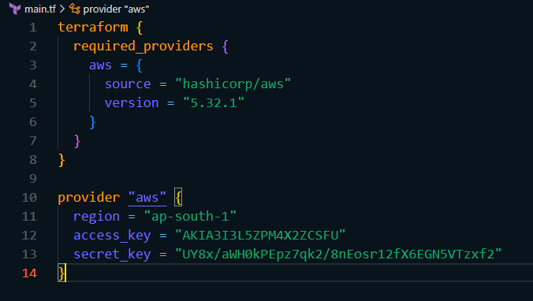

**STEP 3: Create a new file named variables.tf and define variables for region, ami, and instance_type.**

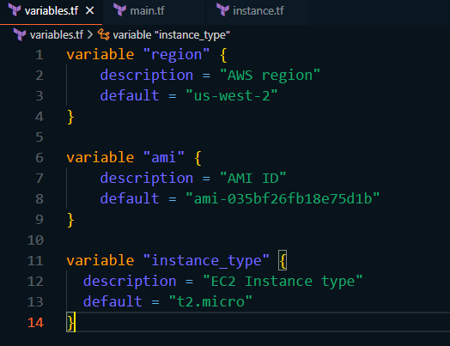

**STEP 4: Create files for two different environments and provide their values.**

* **Create a file named dev.tfvars**

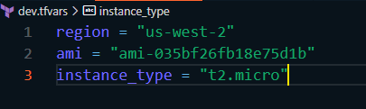

* **Create a file named prod.tfvars**

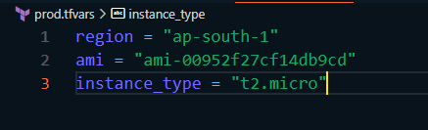

**STEP 5: Initialize and Apply for Dev Environment.**

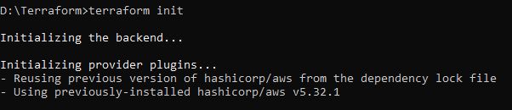

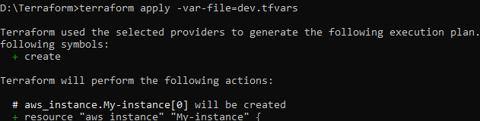



**STEP 6: Initialize and Apply for Prod Environment.**

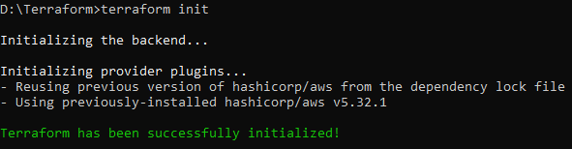

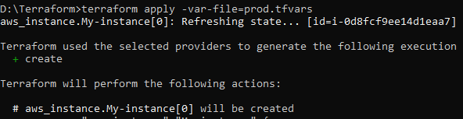



**STEP 7: Clean up the resources after use.**



